Responsi Praktik

Soal 1



1. Amati kestabilan kritis melalui grafik Nyquist!

Script

|  |
| --- |
| G = tf([1],[1000 300 30 1])  figure(1)  nyquist(G) |

Command window

|  |
| --- |
| G =    1  -----------------------------  1000 s^3 + 300 s^2 + 30 s + 1    Continuous-time transfer function. |

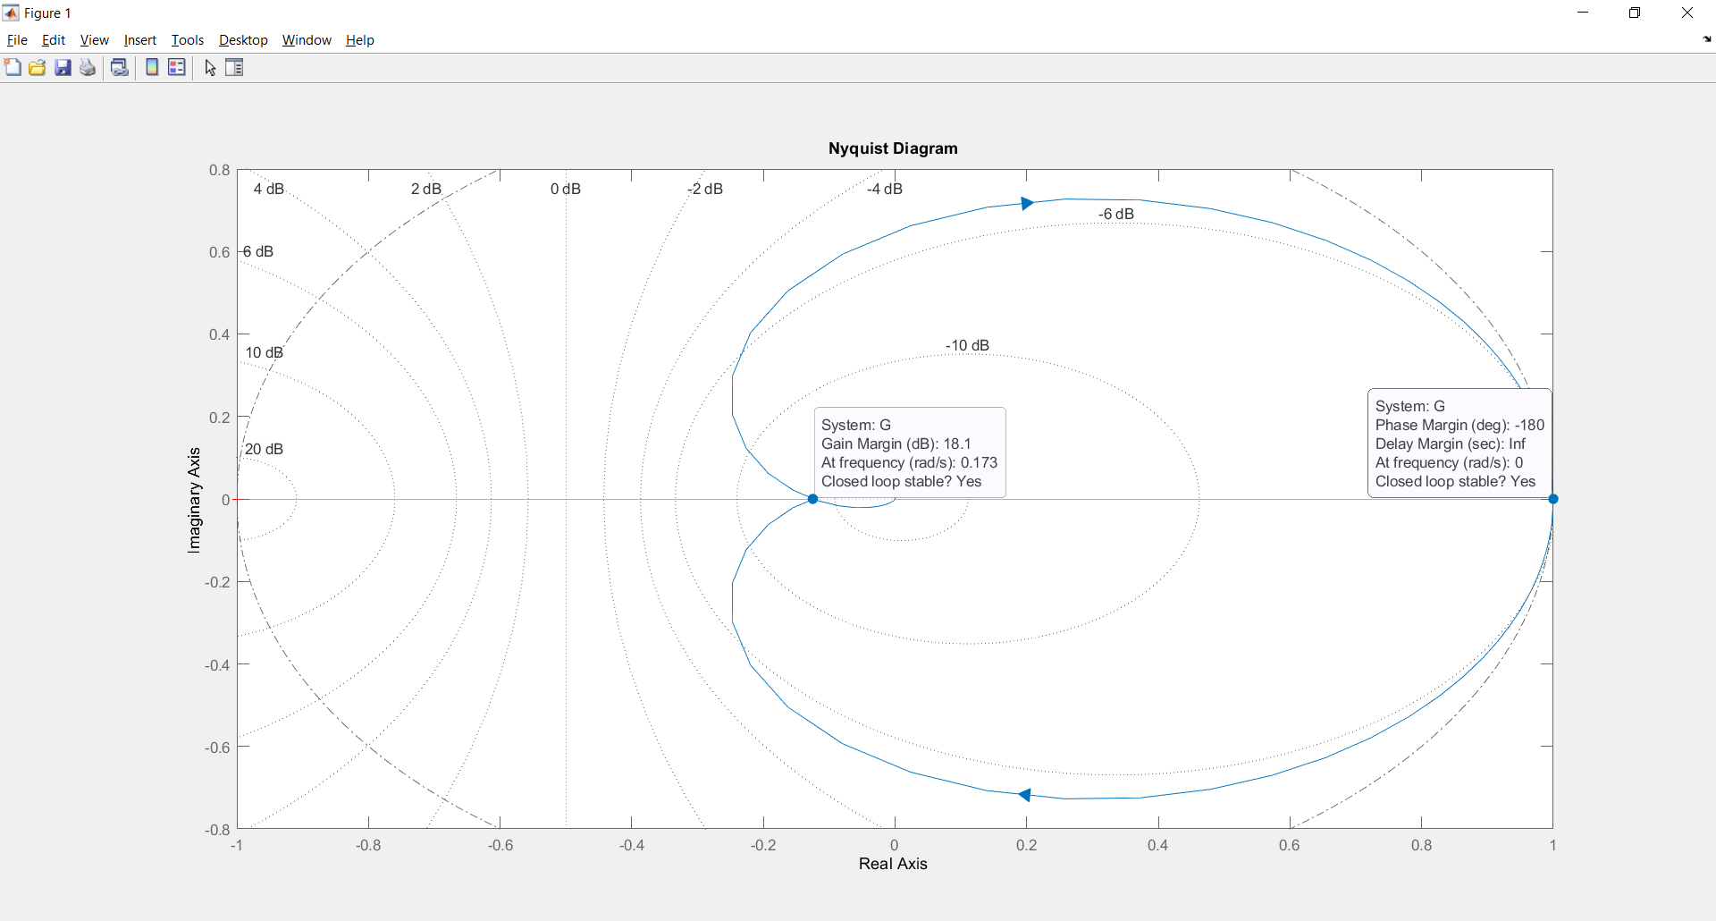

1. Tentukan periode dari kestabilan kritis sistem tersebut!

Script

|  |
| --- |
| Kcr = db2mag(18.1)  Pcr = 2*pi/0.173 |

Command window

|  |
| --- |
| Kcr =  8.0353  Pcr =  36.3190 |

1. Dengan metode kedua, rancang sistem kendali PD dan amati responsnya!

Script

|  |
| --- |
| s = tf('s');  Kp_pd = 0.6*Kcr  Td_pd = 0.125*Pcr  Gc_pd = Kp_pd*(1+Td_pd*s)  Gcl_pd = feedback(Gc_pd*G,1)  figure(2)  step(Gcl_pd)  title('Sistem Kendali PD') |

Command window

|  |
| --- |
| Kp_pd =  4.8212  Td_pd =  4.5399  Gc_pd =    21.89 s + 4.821    Continuous-time transfer function.  Gcl_pd =    21.89 s + 4.821  ------------------------------------  1000 s^3 + 300 s^2 + 51.89 s + 5.821    Continuous-time transfer function. |

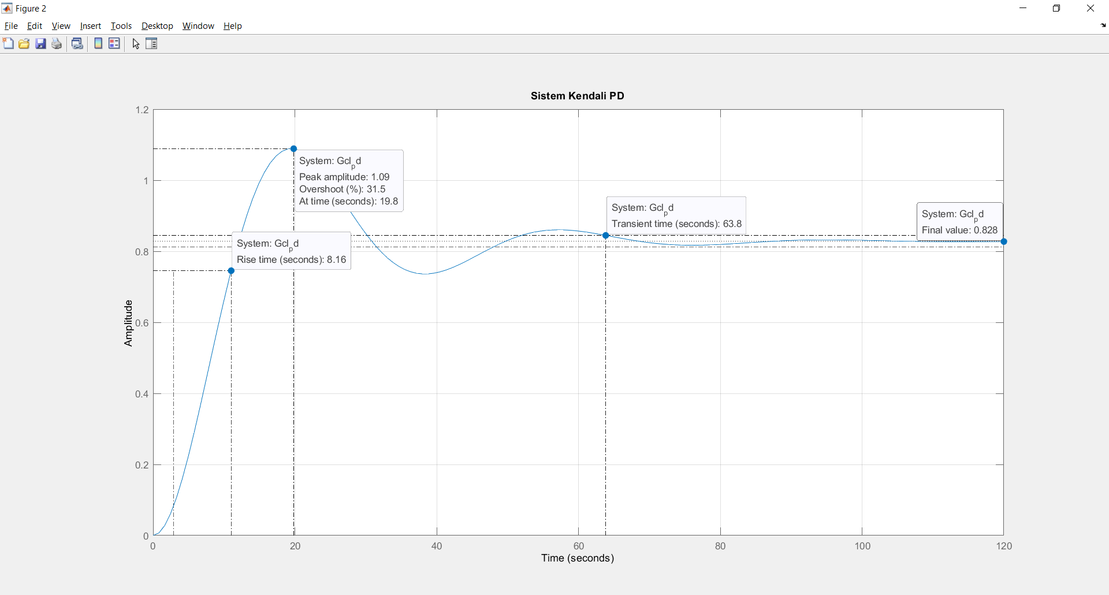

1. Dengan metode kedua, rancang sistem kendali PI dan amati responsnya!

Script

|  |
| --- |
| Kp_pi = 0.45*Kcr  Ti_pi = (1/1.2)*Pcr  Gc_pi = Kp_pi*(1+(1/Ti_pi*s))  Gcl_pi = feedback(Gc_pi*G,1)  figure(3)  step(Gcl_pi)  title('Sistem Kendali PI') |

Command window

|  |
| --- |
| Kp_pi =  3.6159  Ti_pi =  30.2658  Gc_pi =    0.1195 s + 3.616    Continuous-time transfer function.  Gcl_pi =    0.1195 s + 3.616  ------------------------------------  1000 s^3 + 300 s^2 + 30.12 s + 4.616    Continuous-time transfer function. |

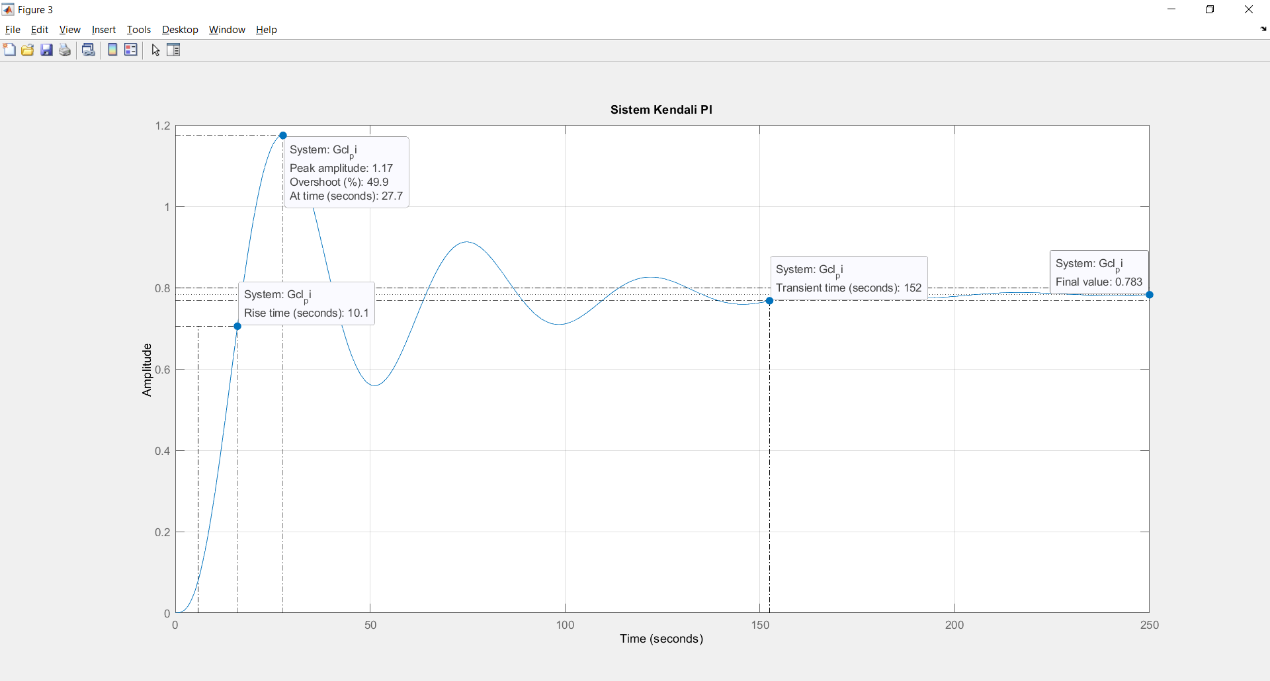

1. Dengan metode kedua, rancang sistem kendali PID dan amati responsnya!

Script

|  |
| --- |
| Kp_pid = 0.6*Kcr  Ti_pid = 0.5*Pcr  Td_pid = 0.125*Pcr  Gc_pid = Kp_pid*(1+(1/(Ti_pid*s)+Td_pid*s))  Gcl_pid = feedback(Gc_pid*G,1)  figure(4)  step(Gcl_pid)  title('Sistem Kendali PID') |

Command window

|  |
| --- |
| Kp_pid =  4.8212  Ti_pid =  18.1595  Td_pid =  4.5399  Gc_pid =    397.5 s^2 + 87.55 s + 4.821  ---------------------------  18.16 s    Continuous-time transfer function.  Gcl_pid =    397.5 s^2 + 87.55 s + 4.821  -----------------------------------------------------  1.816e04 s^4 + 5448 s^3 + 942.2 s^2 + 105.7 s + 4.821    Continuous-time transfer function. |

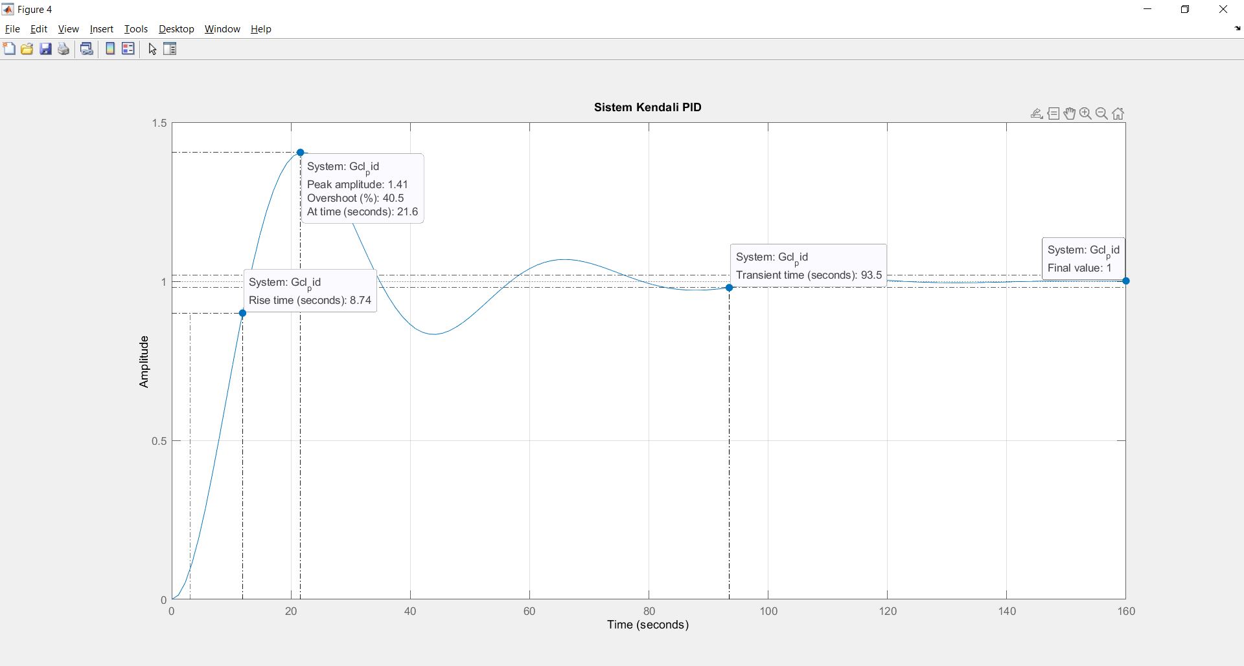

Soal 3

Suatu sistem diketahui memiliki state space sebagai berikut :

A = [1 0 2;

2 3 0;

1 2 3]

B = [1; 0; 0]

1. Tentukan kutub-kutub dari sistem tersebut.

Script

|  |
| --- |
| A = [1 0 2; 2 3 0; 1 2 3]  B = [1 ; 0; 0]  C = [0 0 0;0 0 0;0 0 0]  D = [0]  sys = ss(A,B,C,D)  figure(1)  step(sys)    lamda = eig(A)  P = pole(sys) |

Command window

|  |
| --- |
|  |

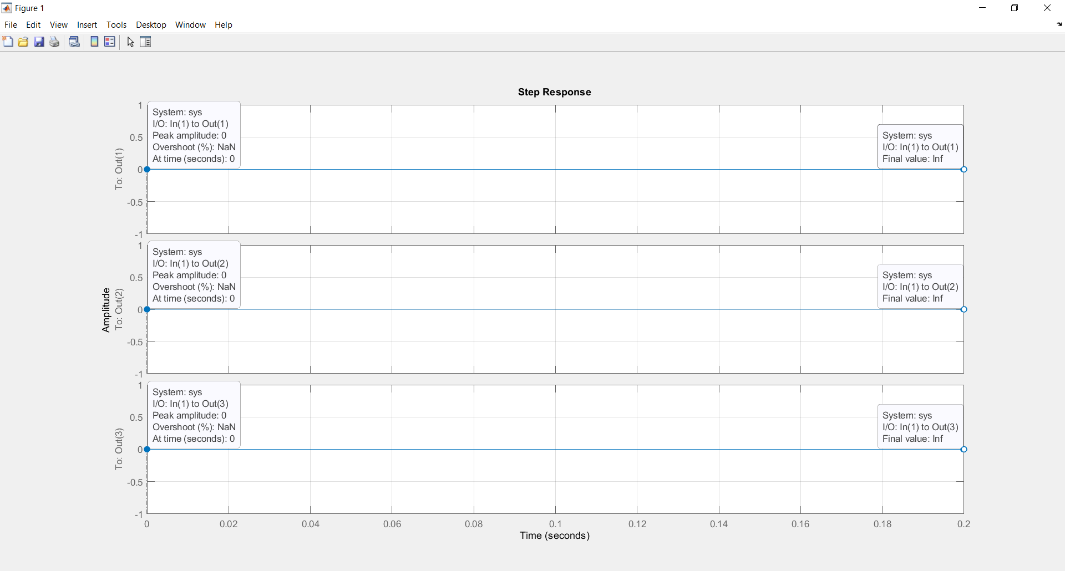

1. Tentukan matriks Q melalui persamaan pembentukan matriks.

Script

|  |
| --- |
| Q = ctrb(sys) |

Command window

|  |
| --- |
|  |

1. Tentukan apakah sistem tersebut stabil.

Script

|  |
| --- |
| isstable(sys) |

Command window

|  |
| --- |
|  |

1. Tentukan matriks umpan balik 𝐾 sedemikian rupa sehingga sistem kalang tertutup tersebut memiliki kutub-kutub [-0.5; -0.5; -0.5]

Script

|  |
| --- |
| P = [-0.5; -0.5; -0.5]  K = place(A,B,P)    sys_fb = ss(A-B*K,B,C-D*K,D) |

Command window

|  |
| --- |
|  |

1. Rancanglah sistem setelah kutub baru ditempatkan

Script

|  |
| --- |
| figure(2)  step(sys_fb) |

Command window

|  |
| --- |
|  |

1. Amati tanggap fungsi sistem sebelum dan setelah dilakukan penempatan kutub

Script

|  |
| --- |
|  |

Command window

|  |
| --- |
|  |